What is Data Validation?

Data Validation is an essential Excel feature that helps control or restrict user inputs/ entries in selected cells. It enables users to set the desired validation rules to control what type of data they can enter into the corresponding cells in an Excel sheet.

Some of the essential tasks (restrictions/ validations) that we can set using the Data Validation are as follows:

* Allow users to put numeric or text entries only
* Allow entering numbers less than, more than and between a specified range
* Allow data inputs of a specific length
* Restrict entries to predefined values in a drop-down list
* Restrict date and time entries outside or within a specific range
* Validate a specific entry based on another cell
* Display an input message informing users what the corresponding cell accepts when the user selects a cell
* Display a warning or error message when the user enters wrong data
* Locate incorrect or wrong entries in the validated cells

Applying Data Validation on any cell or range of cells in an Excel sheet restricts the users from entering any undesired entries in corresponding cells based on the validation rules. For instance, if we set validation to accept only numbers or numeric values, other users or we will not be able to enter any values other than numbers.

Data Validation can be configured to show an input message to users when the respective cell is selected, informing them what is allowed in it, as shown below:

## Data Validation Controls

## The Data Validation feature or its controls can be found on the ribbon under the Data tab. By default, it is placed under the category 'Data Tools'.

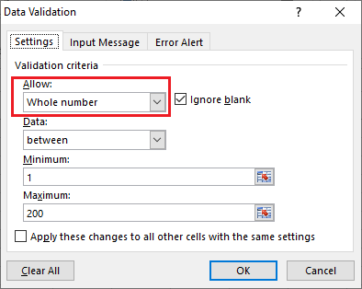 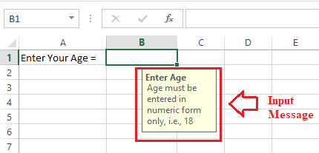

### Input Message Tab

The input message tab has a text box to enter a message displayed as soon as the respective cell is selected. The input message is an optional feature of Data Validation. If we do not define any message as an input message, excel does not show any message when the user selects the respective cell with data validation.

### Error Alert Tab

The error alert tab provides us options to control the way how the validation is enforced. We can set criteria and then use any desired error style to accept or reject the user inputs accordingly. Additionally, we can also display a message to the user informing what the error is or what values must be entered in corresponding cells.

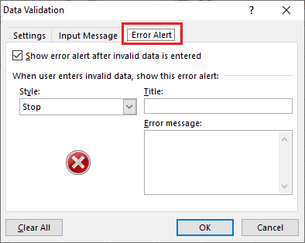

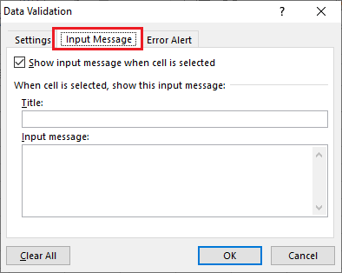

What is pivot table ?

A pivot table is a summary of your data, packaged in a chart that lets you report on and explore trends based on your information. Pivot tables are particularly useful if you have long rows or columns that hold values you need to track the sums of and easily compare to one another.

Used for pivot table

### 1. Comparing Sales Totals of Different Products

Let’s say you have a worksheet that contains monthly sales data for three different products — product 1, product 2, and product 3. You want to figure out which of the three has been generating the most revenue.

### 2. Showing Product Sales as Percentages of Total Sales

Pivot tables inherently show the totals of each row or column when created. That’s not the only figure you can automatically produce, however.

### 3. Combining Duplicate Data

In this scenario, you’ve just completed a blog redesign and had to update many URLs. Unfortunately, your blog reporting software didn’t handle the change well and split the “view” metrics for single posts between two different URLs.

## How to Create a Pivot Table

### Step 1. Enter your data into a range of rows and columns.

Every pivot table in Excel starts with a basic Excel table, where all your data is housed. To create this table, simply enter your values into a set of rows and columns, like the example below.

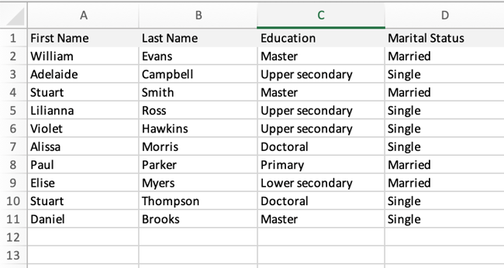

### Step 2. Insert your pivot table.

Inserting your pivot table is actually the easiest part. You’ll want to:

* Highlight your data.
* Go to Insert in the top menu.
* Click Pivot table.

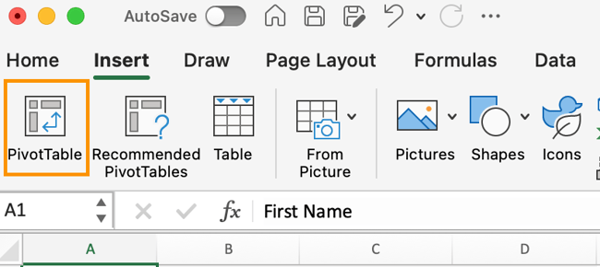

You typically won’t have to edit the options unless you want to change your selected table and change the location of your pivot table.

Once you’ve double-checked everything, click OK.